
Terms and Conditions – The Hungry Hub
Effective Date: July 15, 2026
Welcome to Hungry Hub. These Terms and Conditions ("Terms") govern your use of our website [https://thehungryhub.com] and services. By accessing or using our Service, you agree to be bound by these Terms. If you do not agree to these Terms, please do not use our Service.
- Introduction
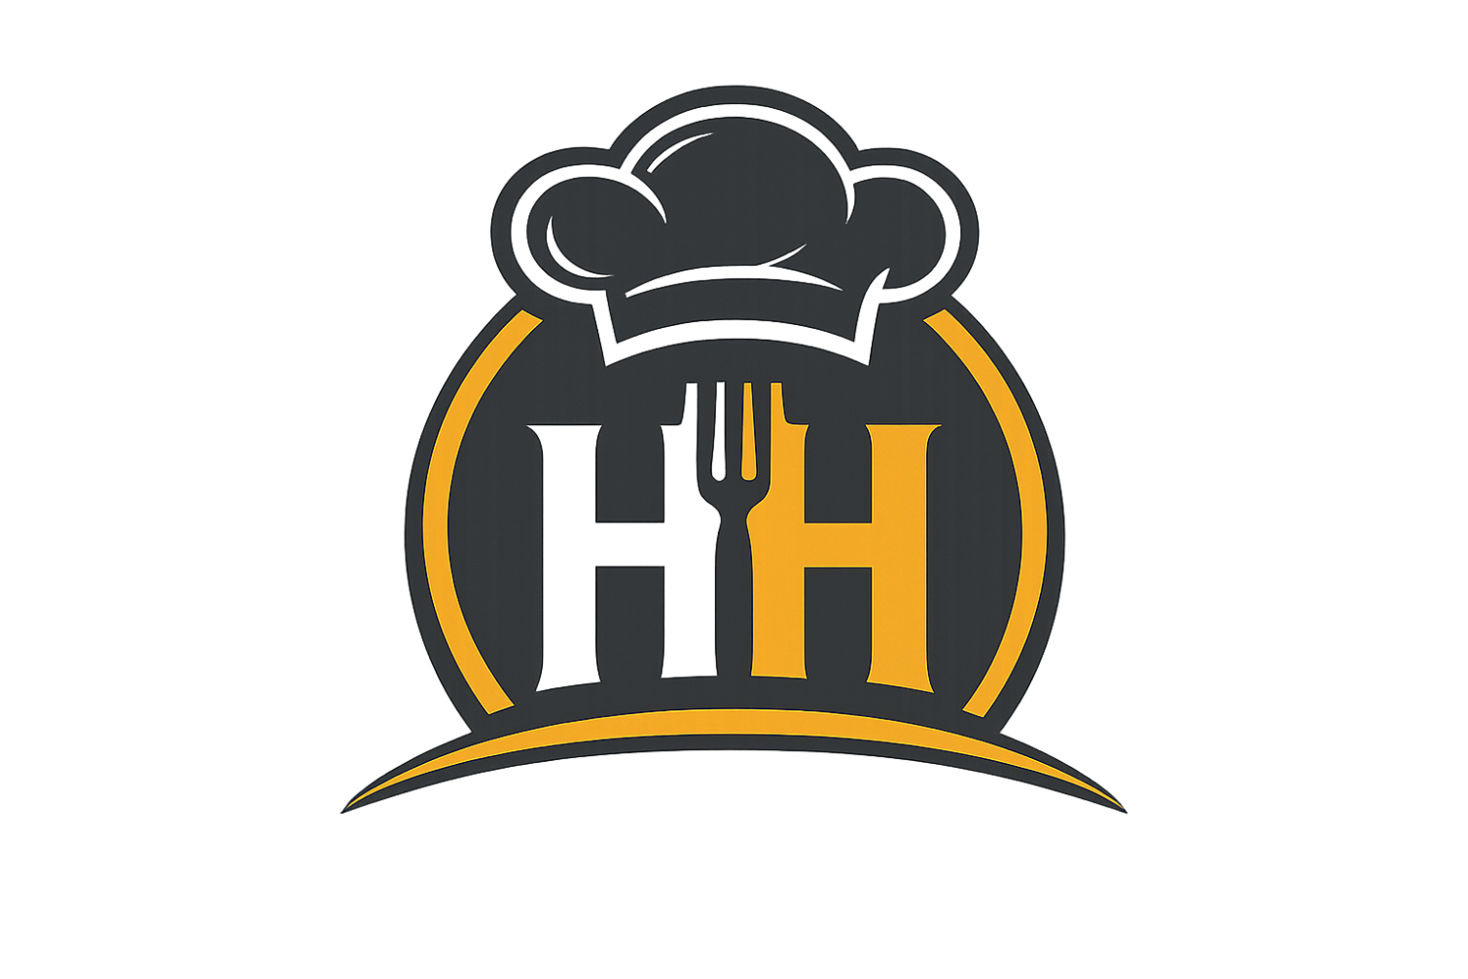
Hungry Hub is a fast-food restaurant and online food delivery platform specializing in burgers, pizzas, deals, and more. Our registered address is:
- Address: Zaki Plaza, Muslim Town, Rawalpindi, Pakistan
- Email: thehungryhub26@gmail.com
- Phone: 0336-0357333
- Website: https://thehungryhub.com
2. Prohibited Use and Activities
You agree not to use our Service for any unlawful or prohibited activities, including but not limited to:
- Posting obscene, violent, or crude content
- Breaking any applicable laws
- Harassing or stalking other users or staff
- Violating copyright or intellectual property laws
- Conducting scams or fraudulent activities
- Hacking, introducing viruses, or tampering with the Service
- Spamming the Service or other users
- Placing fake or duplicate orders
- Misusing promotional offers or discounts
3. Account Termination and Suspension
We reserve the right to suspend or terminate your account if you violate these Terms. Termination may result in the forfeiture and destruction of all information associated with your account. We also reserve the right to refuse service to anyone for any reason at any time.
4. Intellectual Property Rights
All content on the Service, including text, graphics, logos, images, menu items, and software, is the property of Hungry Hub and is protected by copyright, trademark, and other intellectual property laws. You may not use, reproduce, or distribute any content without our prior written consent.
5. Privacy Policy
Our Privacy Policy explains how we collect, use, and protect your personal information. By using the Service, you agree to the terms of this policy. We handle customer data in compliance with applicable laws, including:
- Collecting data for order processing and delivery

- Using data for personalization and improving our services
- Sharing data only with necessary third parties (e.g., delivery partners, payment processors)
- Not sharing your data with third parties for marketing without your explicit consent
6. Product and Menu Information
We reserve the right to modify product information, pricing, promotions, menu items, and availability at any time without notice. We are not responsible for any inaccuracies or errors in product descriptions. All images are for illustrative purposes only and may not represent the actual product. Deals and promotions displayed on the website are subject to change and availability.
7. Pricing and Payments
- All prices are listed in PKR (Pakistani Rupees) and are subject to change without notice.
- We accept the following payment methods:
  - Cash on Delivery (COD)
  - JazzCash (online payment)
  - Credit/Debit Cards (via JazzCash gateway)
- All payments are processed securely through JazzCash payment gateway.
- Failure to make payment may result in order cancellation.
- Prices do not include delivery charges unless specified.
8. Delivery Policy
Delivery Areas & Charges
- Free Delivery: Within 5-7 KM radius from our restaurant address.
- Extra Charges: For deliveries between 7-10 KM radius, additional delivery charges will apply.
- Out of Range: Orders beyond 10-12 KM radius will not be accepted.
Delivery Time
- Minimum Time: 15-20 minutes
- Maximum Time: 30 minutes
- Delivery time may vary based on order volume, traffic conditions, and weather.

Delivery Zones
Our delivery zones are defined based on distance from our restaurant address:
- Zone 1 (0-5 KM): Free Delivery
- Zone 2 (5-7 KM): Free Delivery
- Zone 3 (7-10 KM): Extra Delivery Charges Apply
- Zone 4 (>10 KM): Not Deliverable
Important Notes
- We deliver only within the defined radius in Rawalpindi.
- We are not responsible for delays caused by third-party delivery partners or traffic conditions.
- Delivery availability is subject to weather conditions and operational capacity.
9. Order Confirmation and Cancellation
Order Confirmation
- All orders require confirmation via phone call before processing.
- You will receive a call from our team to confirm your order details.
- Your order will be processed only after confirmation.
Order Cancellation
- Before Confirmation Call: You can cancel your order anytime.
- During Confirmation Call: You can cancel your order by informing our team.
- After Confirmation: Cancellation is at the discretion of management.
- Processing Orders: Once the order is being prepared, cancellation may not be possible.
10. Return and Refund Policy
Return Policy
- Due to the nature of food products, returns are only accepted in case of:
  - Quality Compromised: Food quality is below standard or spoiled.
  - Delayed Delivery: Delivery time exceeds the maximum limit (30 minutes).
  - Incorrect Order: Wrong items delivered.
  - Missing Items: Items missing from the order.
Refund Process

- Refunds will be processed within 5-7 business days after verification.
- Refund will be issued via the original payment method.
- Only the order amount will be refunded (delivery charges may not be refunded).
- We reserve the right to inspect claims before processing refunds.
11. User-Generated Contributions
If you submit reviews, comments, or feedback, you grant us a non-exclusive, royalty-free license to use them. We may remove any content that violates these Terms or is deemed inappropriate.
12. Governing Law and Dispute Resolution
These Terms are governed by the laws of Pakistan. Any disputes will be resolved through arbitration in Rawalpindi, Pakistan.
13. Warranties and Disclaimers
- All food products are prepared in accordance with food safety standards.
- Products are sold "as is" without warranties, except as required by law.
- We disclaim all implied warranties, including but not limited to fitness for a particular purpose.
- We are not responsible for allergic reactions; customers are advised to check ingredients before ordering.
- We reserve the right to refuse service or cancel orders at our discretion.
14. Limitation of Liability
To the fullest extent permitted by law, Hungry Hub shall not be liable for any indirect, incidental, special, consequential, or punitive damages, including but not limited to:
- Loss of profits, revenue, or data
- Loss of goodwill or reputation
- Any damages arising from the use of our Service
Our total liability shall not exceed the amount paid by you for the specific order.
15. Changes to Terms
We may update these Terms at any time. Continued use of our Service after changes constitutes acceptance of the new Terms. We encourage you to review these Terms periodically.
16. Contact Us

For questions, concerns, or complaints, please contact us:
- Email: thehungryhub26@gmail.com
- Phone: 0336-0357333
- Address: Zaki Plaza, Muslim Town, Rawalpindi, Pakistan
- Website: https://thehungryhub.com
By using Hungry Hub, you agree to these Terms and Conditions.
🔒 Privacy Policy - Hungry Hub
Effective Date: July 15, 2026
Welcome to Hungry Hub. We respect your privacy and are committed to protecting your personal data. This Privacy Policy explains how we collect, use, and safeguard your information.
1. Information We Collect
a) Personal Information
When you use our Service, we may collect:
- Name
- Email Address (thehungryhub26@gmail.com)
- Phone Number (0336-0357333)
- Delivery Address
- Order History
- Payment Information (processed securely via JazzCash)
b) Technical Information
- IP Address
- Browser Type and Version
- Device Information
- Location Data (if you allow location access)
- Cookies and Usage Data
2. How We Use Your Information
We use your information to:
- Process and deliver your orders
- Send order confirmations and updates via email/SMS

- Contact you for order confirmation via phone
- Improve our menu and services
- Personalize your experience
- Respond to your inquiries and feedback
- Process payments (via JazzCash)
- Send promotional offers (only with your consent)
3. Legal Basis for Processing
We process your personal data based on:
- Contractual Necessity: To fulfill your orders
- Legitimate Interest: To improve our services
- Consent: For marketing communications (you can opt-out anytime)
- Legal Obligation: To comply with applicable laws
4. How We Share Your Information
We do not sell or rent your personal information. We may share your data with:
Recipient | Purpose
Delivery Partners | To deliver your orders
JazzCash | Payment processing
Legal Authorities | If required by law
Service Providers | For technical support and website maintenance

5. Data Retention
We retain your personal data for as long as necessary to:
- Fulfill the purposes outlined in this policy
- Comply with legal obligations
- Resolve disputes
- Enforce our agreements
We securely delete or anonymize data when it is no longer needed.
6. Data Security
We implement industry-standard security measures to protect your data:

- Encryption: SSL/TLS for data transmission
- Access Control: Limited access to personal data
- Secure Servers: Data stored on secure servers
However, no method of transmission over the internet is 100% secure, and we cannot guarantee absolute security.
7. Your Rights
You have the right to:
- Access: Request a copy of your personal data
- Rectification: Request correction of inaccurate data
- Erasure: Request deletion of your data (subject to legal obligations)
- Restriction: Request restriction of processing
- Portability: Request transfer of your data
- Objection: Object to processing for marketing purposes
- Withdraw Consent: Withdraw consent for marketing communications
To exercise your rights, contact us at: thehungryhub26@gmail.com
8. Cookies
We use cookies to enhance your experience. Types of cookies we use:
Cookie Type | Purpose
Essential | Required for website functionality
Analytics | To understand how visitors use our website
Preference | To remember your preferences
Marketing | To deliver relevant advertisements (only with consent)
You can disable cookies in your browser settings, but this may affect some features of our website.
9. Third-Party Links
Our website may contain links to third-party websites. We are not responsible for the privacy practices of these third-party sites. We encourage you to read their privacy policies.
10. Children's Privacy

Our Service is not intended for children under 13. We do not knowingly collect personal information from children under 13. If we learn we have collected personal data from a child under 13, we will delete it.
11. International Data Transfers
We do not transfer your personal data outside of Pakistan. All data is stored and processed locally.
12. Changes to Privacy Policy
We may update this Privacy Policy from time to time. We will notify you of any changes by:
- Posting the new policy on this page
- Updating the "Effective Date" at the top
- Sending an email notification (if you have provided your email)
We encourage you to review this policy periodically.
13. Complaints
If you have a complaint about how we handle your personal data, please contact us:
- Email: thehungryhub26@gmail.com
- Phone: 0336-0357333
You also have the right to lodge a complaint with the relevant data protection authority in Pakistan.
14. Contact Us
If you have questions about this Privacy Policy, contact us:
- Email: thehungryhub26@gmail.com
- Phone: 0336-0357333
- Address: Zaki Plaza, Muslim Town, Rawalpindi, Pakistan
- Website: https://thehungryhub.com
By using Hungry Hub, you consent to this Privacy Policy.

